Hula-Hooping

Welcome to the Cambridgeshire and Peterborough Virtual School Games hosted by Living Sport and the Cambridgeshire and Peterborough School Games Organisers.

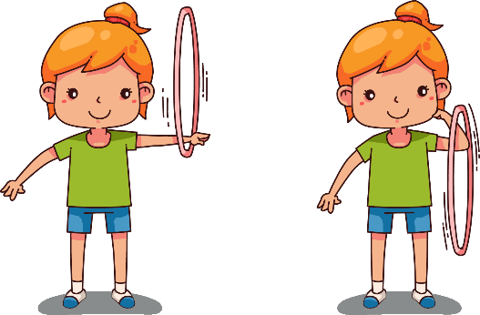

Who for?

This is aimed at all children in Key Stage 1 and 2.

When

Commencing Week beginning 28th February 2022.

FORMAT

There are 3 Hula-Hooping challenge levels:

* Bronze – Beginners
* Silver – Intermediate hula-hoopers
* Gold – Advanced hula-hoopers

The children can have as many attempts as they would like but to achieve the appropriate level they must perform 10 of each skill without a mistake.

THEME

The focus of this event is determination and self-belief.

How to enter

Enter via our website: [www.improveit.education/events/hula-hooping-week/](http://www.improveit.education/events/hula-hooping-week/)

Please send results to [HScottodiMarrazzo@improveit.ltd](mailto:HScottodiMarrazzo@improveit.ltd)

RESOURCES

Each level can be found on the attached instruction sheets.

A results sheet is also included so you can track children’s progress.

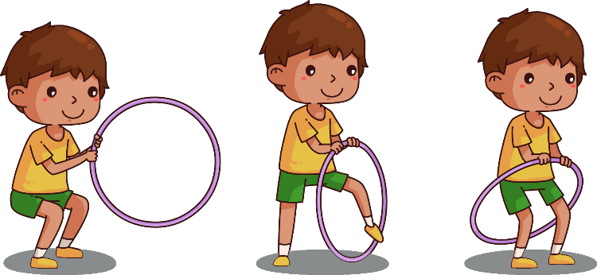

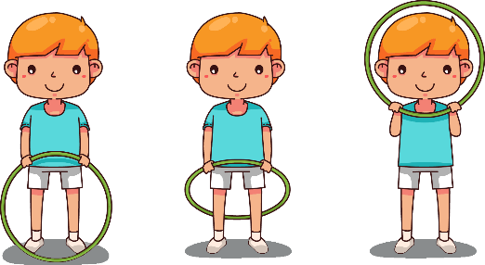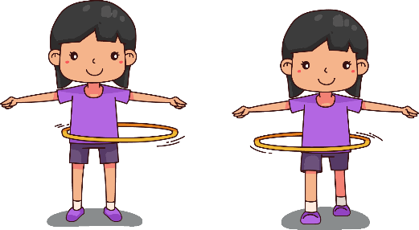

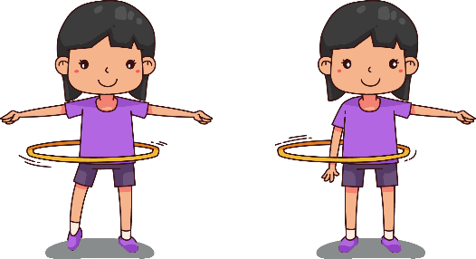

2. Sway and Hula

Objective: As you are hula hooping, shift your weight from one foot to the other, keeping your toe in contact with the ground.

1. Basic Waist Hooping

Objective: For both techniques, stand with head up and shoulders down and relaxed. Use hands to start the hoop. If one foot is in front of the other, move hips backwards and forwards. If legs are parallel in wide stance, move hips side to side.

Tip: To increase the speed of the hoop, raise your arms above your head and hold there.

Hula-Hoop - bronze

3. Skipping Hula on the Spot

Objective: Hold the hoop vertically in front of you. Hands should be shoulder width apart, knuckles facing upwards. Jump through the hoop and swivel it behind you, over your head and back to the start position. Repeat for a continuous skip.

Hula-Hoop - Silver

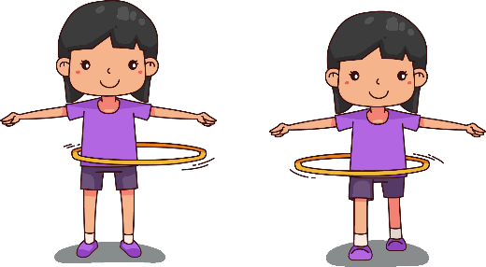

1. Hand Dip Hula

Objective: This calls for careful timing! Whilst hooping, dip your right hand into the space between the hoop and your body. Repeat with left hand.

Can you alternate hands continuously?

2. Tap and Hula

Objective: Start with feet close together. Step right foot out to the side, tap the ground and return to the middle. Repeat with left leg. Tap continuously, left and then right.

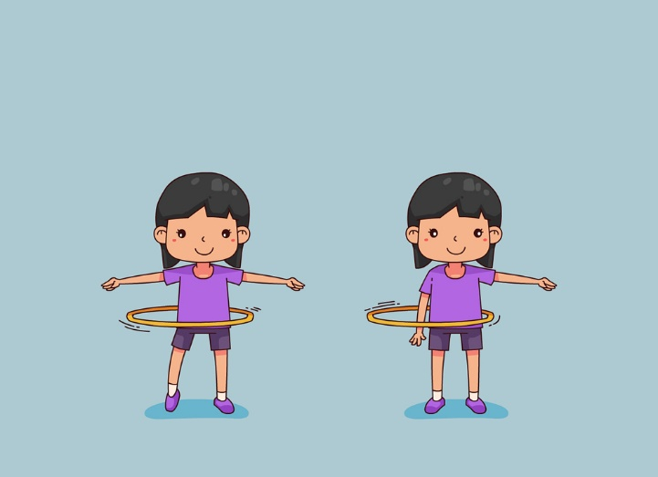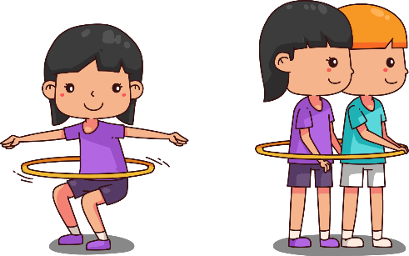

3. The Hula Shimmy

Objective: If the hoop falls you need to catch it with your waist. Quickly bend your knees to catch the hoop then stand again to continue hooping.

Tip: To increase the speed of the hoop, raise your arms above your head and hold there.

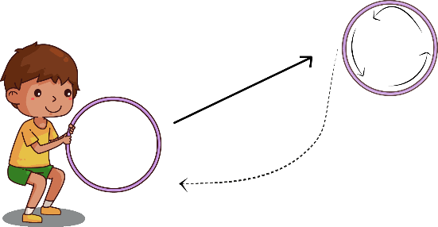

4. Roll and Return

Objective: Hold the hoop vertically in one hand. As you throw the hoop away from you, flick your wrist to spin it back towards you on release. When the hoop touches the ground, it should come back.

Hula-Hoop - Gold

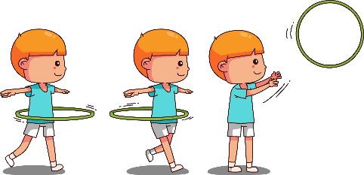

1. Walking Hula

Objective: Start with the right foot in front of the left. Whilst hooping take a small step forwards. Bring feet back together then take another step forwards. Keep stepping forwards.

2. Clock Hula

Objective: Imagine you are standing in the middle of a clock face. The left leg stays in the centre as ‘pivot point’ and the right leg moves to the different positions on the clock between 12 and 6. Swap legs so that the left leg moves between 6 and 12.



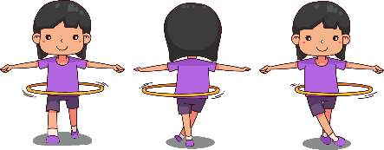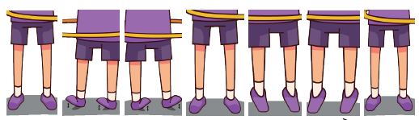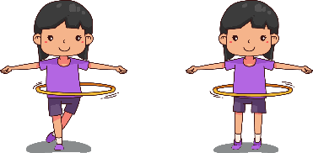

4. Dance Routine

Objective: Using the ideas, join different moves together to make a simple routine. Add music if you want for a sensational display.

Here is an example:

1. Static hoop for 8.

2. Step right leg forward then return to centre followed by 2 static hoops.

3. Step left leg forward then return to centre followed by 2 static hoops.

4. Side step to the right then follow with 2 static hoops.

5. Side step to the left then follow with 2 static hoops.

6. Walk forward for four, turn and walk back for 4 (turn to face front).

7. Swivel hula left and right for 5 pivots each way.

3. Swivel Hula

Objective: Whilst hooping in the wide stance, shift weight on to the heels of both feet and pivot slightly to the left. Shift weight onto both toes then pivot heels to the left. Repeat continuously to travel. Can you travel to the right as well as the left?